1. Scope Of Work
   1. Back End: Data Acquisition and Processing

Following diagram indicates the list of backend modules to be developed

* 1. Scope Overview
     1. Building partner using purchase order data for T0 – T1 tier.
     2. Using T1 companies create partner networks for the T1 – T2 tier.
     3. Crawlers for credit health of companies from CAPIQ.
     4. Crawlers for financial scores of companies from CSI Market.
     5. Analysing structural risk for T0 company using purchase order data and impacts T0’s revenue.
     6. Analysing temporal risk for companies except for T0. Temporal risk Such as financial, reputation, weather, logistics risk, etc.
     7. Building SQL data model for faster application.
     8. Creating multiple KPI’s.

1. Data Model
   1. 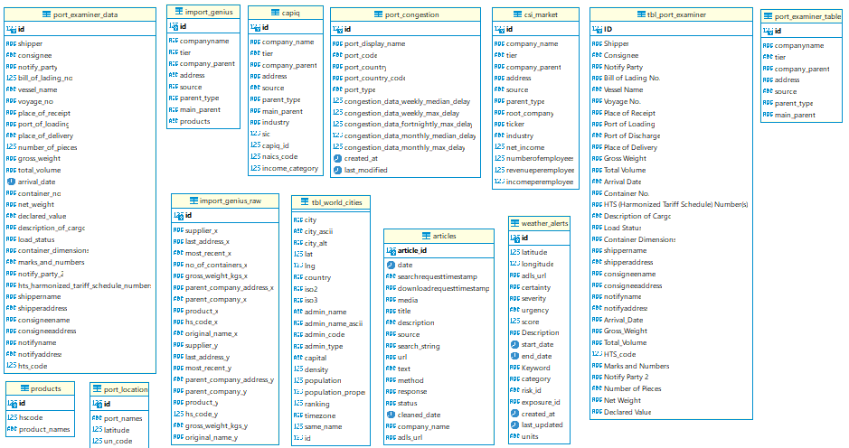First Layer (Raw data layer)

* 1. Diagram, schematic

     Description automatically generatedSecond Layer (Normalised layer)
  2. Third Layer (Application layer)

1. Backend (Low level design)
   1. DataMyne Crawler
      1. Description

Reading data from database for T1 company name extracted from purchase order data and downloading data for partner network T1 to T2 from DataMyne website and storing it into database.

* + 1. Flowchart

* 1. Extreme Weather
     1. Description

By passing location to the API with alerts Endpoints it will give information about weathers in Database. The data for each company will be extracted for last 1 year.

* + 1. 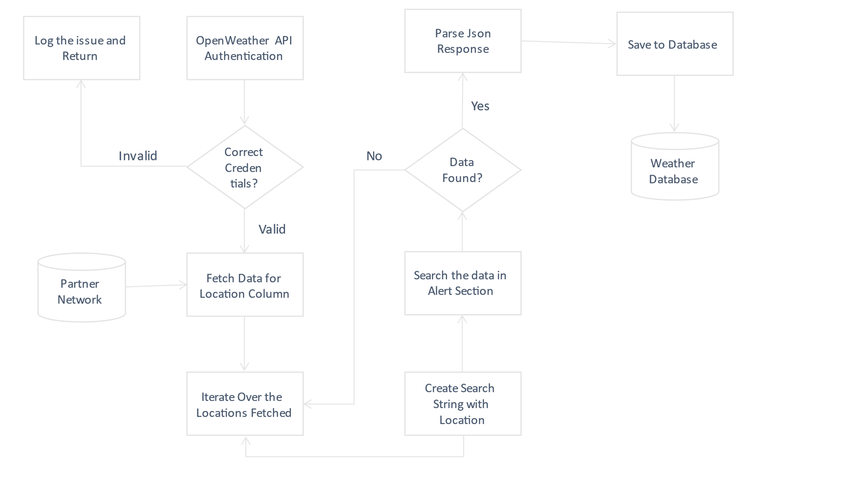 Flowchart
  1. News Downloader
     1. Description

Searches for the news about a company using the words mentioned in taxonomy for each type of risk and save the data in Database and ADLS (Azure Data Lake Service). The data for each company will be extracted for last 1 year.

* + 1. Flowchart

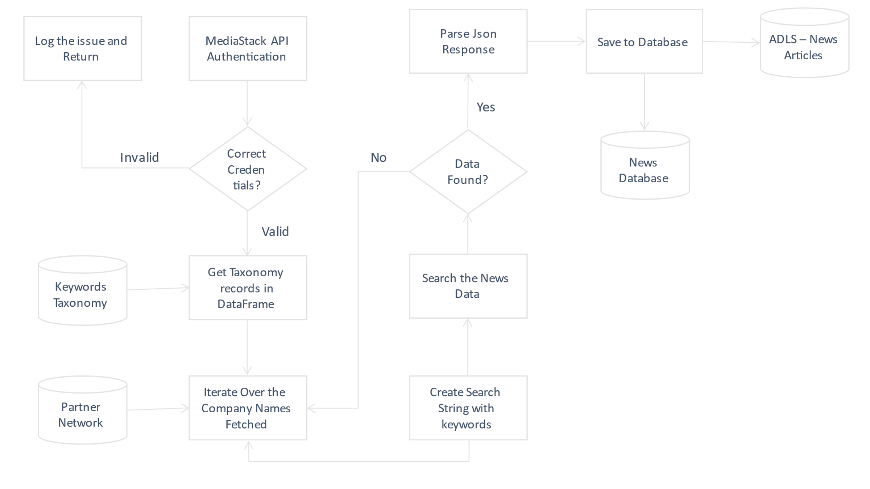

* 1. CAPIQ Credit Health Crawler
     1. Description

Extracting credit health score from CapIQ and storing into database for each company. This will be used as financial risk for a company. The data for each company will be extracted for last 1 year.

* + 1. 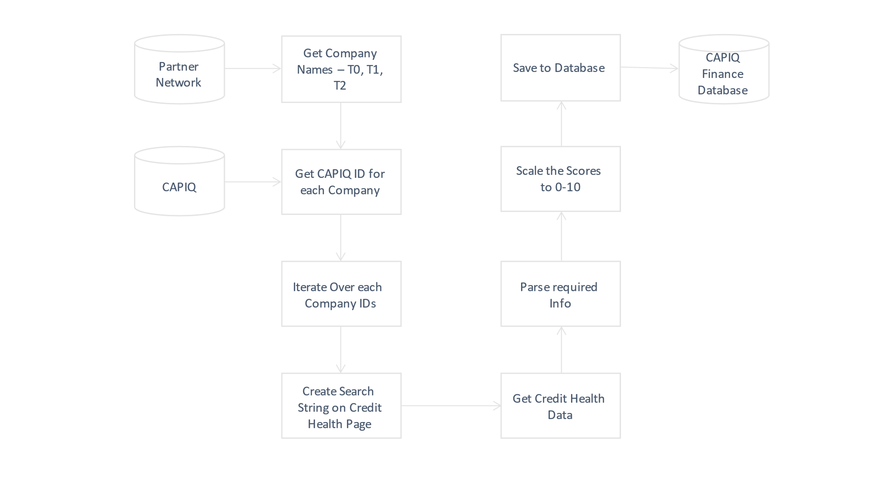 Flowchart
  1. CSI Market Financial Crawler
     1. Description

Reading data from database for partner company names of T0 company and scraping financial from CSI Market for those companies.

* + 1. Diagram

       Description automatically generated Flowchart
  1. Purchase Order Partner Network
     1. Description

Reading Purchase Order data from ADLS and Creating partner network through it, analysing data for various KPI’s and storing in it database.

* + 1. Flowchart

* 1. Go Comet API
     1. Description

Requesting data from GO Comet API on regular intervals of port congestion and mapping it to company’s port for calculating risk.

* + 1. Flowchart

* 1. Risk Scoring Engine

Following table indicates how the scoring mechanism will work across different risk types.

|  |  |  |
| --- | --- | --- |
|  | Direct | Indirect |
| Weather | Using the OpenWeather API will extract the weather alerts for city of the company.  After searching for the alert using specific city, description of alert will be stored in database.  Using the article, we will extract the words mentioned in taxonomy. According to the words extracted from the article we will quantify the score mentioned in taxonomy. | Using the OpenWeather API will extract the weather alerts for State and Country of the company.  After searching for the alert using specific state and country, description of alert will be stored in database.  Using the article, we will extract the words mentioned in taxonomy. According to the words extracted from the article we will quantify the score mentioned in taxonomy. |
| Finance | For a company we will search for the credit health ratio given by CapIQ and scale it for a company.  Additionally, using company name and keywords from taxonomy, the articles (From MediaStack and CapIQ) will be short listed to determine relevance in terms of financial risk.  Later both the scores will be combined to indicate direct financial risk. | We will calculate the financial risk using news from MediaStack API.  Using industry and keywords from taxonomy, the articles will be short listed to determine relevance in terms of indirect financial risk. |
| Transport | We will calculate the transport risk using MediaStack API for a company.  After searching for the news using taxonomy words like lockdown, curfew, etc. we will extract the article text into server  Using the article text, we will extract the words mentioned in taxonomy. According to the words extracted from the article text we will quantify the score mentioned in taxonomy. | We will calculate the transport risk using MediaStack API for a company.  After searching for the news using taxonomy words like port closure, etc. we will extract the article text into server  Using the article text, we will extract the words mentioned in taxonomy. According to the words extracted from the article text we will quantify the score mentioned in taxonomy. |